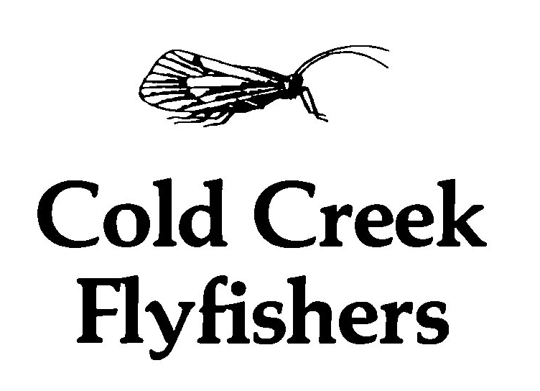

The club was established in 1976, and has an agreement with certain land owners on a section of Cold Creek in Northumberland County. This water is being developed into a superb fishery for naturally reproduced brown and brook trout. A no-kill, single barbless hook fly fishing only policy is in effect on the preserve.

Meetings include presentations by guest speakers, instruction in fly fishing and fly tying, films, etc.

One of the main objectives of the club is conservation of wild trout streams. We are actively involved in stream rehabilitation and improvement projects in the Lower Trent area.

Annual dues:
Adult - $75.00
Family- $85.00
Youth - $25.00
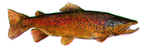
Initiation Fee:
Adult - $25.00
Family- $25.00
Youth - $10.00

Detach the application below and mail to the following address.

Name: _________________________
Address: _________________________
_________________________
_________________________
Phone: _________________________
Email: _________________________

Cold Creek Flyfishers.
c/o John Wilson
732 Milford Drive
Kingston, Ontario
K7P 1C6

